9.58: The analysis is identical to that of Example 9.13, with the lower limit in the integral being zero and the upper limit being R, and the mass 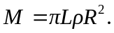 The result is 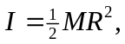 as given in Table 